Math 227 – Elementary Statistics: A Brief Version, 5/e Bluman

Ch 7.1 pg. 364 #11, 13, 15, 17, 19, 21, 23, 25
11. Reading Scores: A sample of the reading scores of 35 fifth-graders has a mean of 82. The standard deviation of the sample is 15.
Note: All values we calculated were rounded.
- Find the best point estimate of the mean.

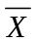 Is the best point estimate for, therefore, the best point estimate of the population mean is 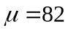

- Find the 95% confidence interval of the mean reading scores of all the fifth-graders.
n=35, Confidence interval (C.I.) = 0.95, 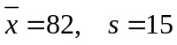

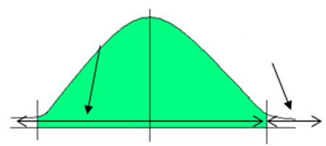
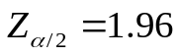
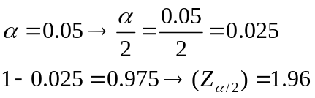
0.95
0.025
0.975
0.95

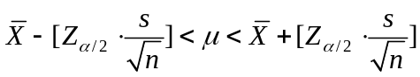
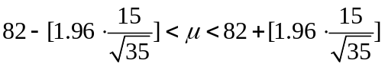

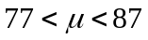

- Find the 99% confidence interval of the mean reading scores of all fifth graders.

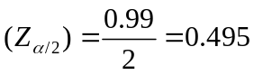
To find 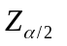 go to table E and look for area = .4950, the corresponding z value for this area is 2.58.
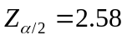

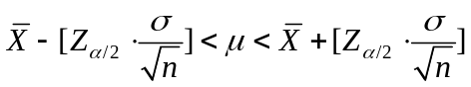
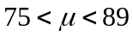

- Which interval is larger? Why?

The 99% confidence interval is larger because the confidence level is larger.

13. Workers’ Distractions A recent study showed that the modern working person experiences an average of 2.1 hours per day of distractions (phone calls, e-mails, impromptu visits, etc.). A random sample of 50 workers for a large corporation found that these workers were distracted an average of 1.8 hours per day and the population standard deviation was 20 minutes. Estimate
the true mean population distraction time with 90% confidence, and compare your answer to the results of the study.
n=50, Confidence interval (C.I.) = 0.90, 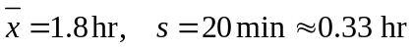

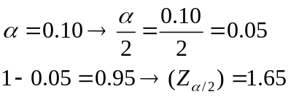
0.90
0.05
0.95
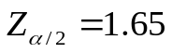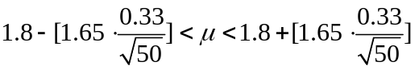
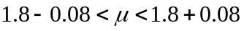
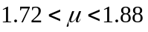

The estimate is lower.

15. Actuary Exams A survey of 35 individuals who passed the seven exams and obtained the rank of Fellow in the actuarial field finds the average salary to be $150,000. If the standard deviation for the population is $15,000, construct a 95% confidence interval for all Fellows.
n=35, Confidence interval (C.I.) = 0.95, 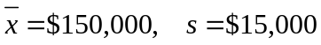

0.95
0.025
0.975
0.95

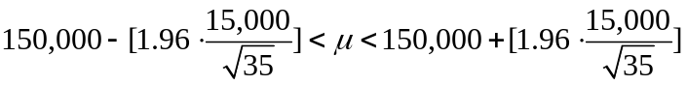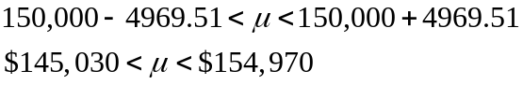

17. Television viewing a study of 415 kindergarten students showed that they have seen on average 5000 hours of television. If the sample standard deviation is 900, find the 95% confidence level of the mean for all students. If a parent claimed that his children watched 4000 hours, would the claim be believable?
n=415, Confidence interval (C.I.) = 0.95, 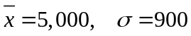
0.95
0.025
0.975
0.95
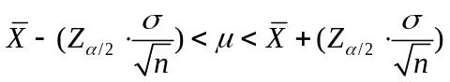
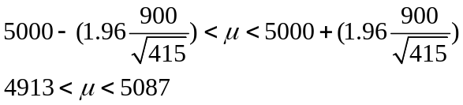
Since 4000 hours is not within a 95% confidence interval, we can say that the claim is not believable.

19. Hospital Noise Levels Noise levels at various areas urban hospitals were measured in decibels. The mean of the noise levels in 84 corridors was 61.2 decibels, and the standard deviation was 7.9. Find the 95% confidence interval of the true mean.
n=84, Confidence interval (C.I.) = 0.95, 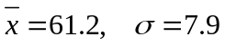
0.95
0.025
0.975
0.95
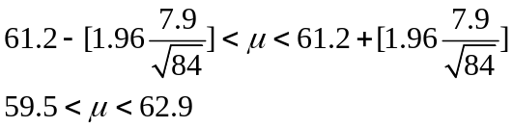

21) Time on Homework A university dean of students whishes to estimate the average number of hours students spend doing homework per week. The standard deviation from a previous study is 6.2 hours. How large a sample must be selected if he wants to be 99% confident of finding whether the true mean differs from the sample mean by 1.5 hours?
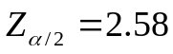
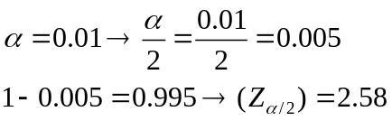
0.95
0.005
0.995
0.99
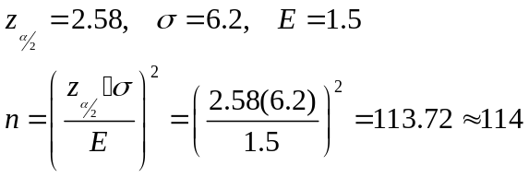
Therefore, to be 99% confident that the estimate is within 1.5 hours of the true mean homework hours per week, the university dean of students needs a sample size of at least 114 university students.

23. Chocolate Chips per Cookie It is desired to estimate the mean number of chocolate chips per cookie for a large national brand. How many cookies would have to be sampled to estimate the true mean number of chips per cookie within 2 chips with 98% confidence?
Assume that 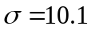 chips.
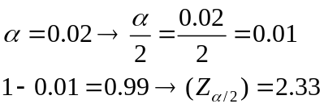
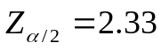
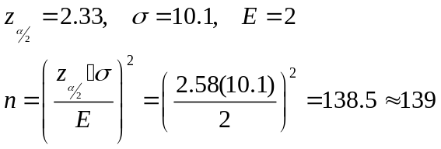
0.95
0.001
0.99
0.98
Therefore, to be 98% confident that the estimate is within 1.5 hours of the true mean number of chocolate chips per cookies, at least 139 cookies have to be sampled.

25. National Accounting Examination If the variance of a national accounting examination is 900, how large a sample is needed to estimate the true mean score within 5 points with 99% confidence?
0.95
0.005
0.995
0.99
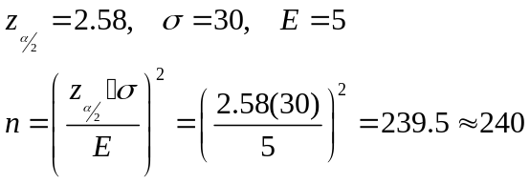
Therefore, to be 99% confident that the estimate is within 5 points of the true mean number of the true mean score, at least 240 samples is required.

Section 7-2 pg 372 #’s 4, 5, 7, 10, 13, 16, 17

4. Find the values for each.
- 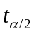 and n =18 for the 99% confidence interval (C.I.) for the mean
d.f. = 17
From table F, confidence interval=99% and d.f. =17 → =2.898
- and n =23 for the 95% confidence interval (C.I.) for the mean
d.f. = 22
From table F, confidence interval=95% (C.I.) and d.f. =22 → =2.074
- and n =15 for the 98% confidence interval (C.I.) for the mean
d.f. = 14
From table F, confidence interval=98% (C.I.) and d.f. =14 → =2.624
d) and n =10 for the 90% confidence interval (C.I.) for the mean
d.f. = 9
From table F, confidence interval=90% (C.I.) and d.f.=9 → =1.833
e) and n =20 for the 95% confidence interval (C.I.) for the mean
d.f. = 19
From table F, confidence interval=95% (C.I.) and d.f. =19 → =2.093

5. Hemoglobin The average hemoglobin reading for a sample of 20 teachers was 16 grams per 100 milliliters, with a sample standard deviation of 2 grams. Find the 99% confidence interval of the true mean.
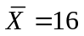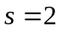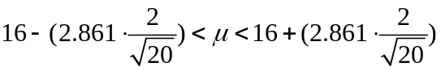
n=20 C.I. 99% =2.861 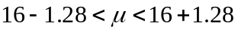
Degrees of freedom= 20-1=19 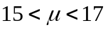

7. Women Representatives in State Legislature a state representative wishes to estimate the mean number of women representatives per state legislature. A random sample of 17 states is selected, and the number of women representatives is shown. Based on the sample, what is the point estimate of the mean? Find the 90% confidence interval of the mean population. (Note: The population mean is actually 31.72, or about 32.) Compare this value to the point estimate and the confidence interval. There is something unusual about the data. Describe it and state how it would affect the confidence interval.
5 33 35 37 24 31 16 45 19 13 18 29 15 39 18 58 132
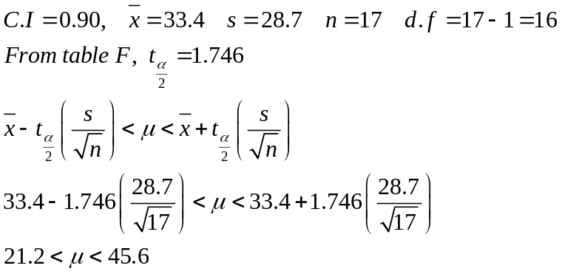
The 90% confidence interval for the mean population is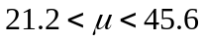.
Based on the data from the sample, the point estimate of the mean is 33.4 which is close to the actual population mean of 32. Notice that a mean of 32 is within the 90% confidence interval. What is unusual about the data is that 132 is too large compare to the other values. Therefore this value affects the sample mean and for this reason the mean is not the best point estimate.

10. Dance Company Students The number of students who belong to the dance company at each of several randomly selected small universities is shown below. Estimate the true population mean size of a university dance company with 99% confidence.

21 25 32 22 28 30 29 30
47 26 35 26 35 26 28 28
32 27 40

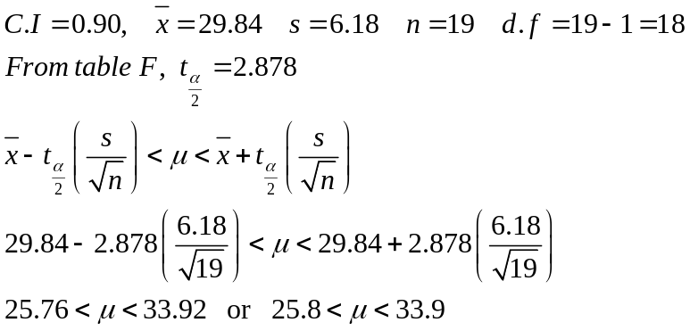
The 99% confidence interval for the mean population is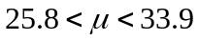.

13. Students per Teacher in U.S. Public Schools The national average for the number of students per teacher for all U.S. public schools is 15.9. A random sample of 12 school districts from a moderately populated area showed that the mean number of students per teacher was 19.2 with a variance of 4.41. Estimate the true mean number of students per teacher with 95% confidence. How does your estimate compare with the national average?

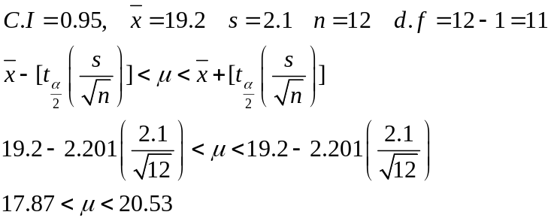
The 95% confidence interval of the true mean is 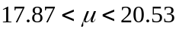.

16. Hospital Noise Levels For a sample of 24 operating rooms taken in the hospital study mentioned in Exercise 19 in Section 7–1, the mean noise level was 41.6 decibels, and the standard deviation was 7.5. Find the 95% confidence interval of the true mean
of the noise levels in the operating rooms.

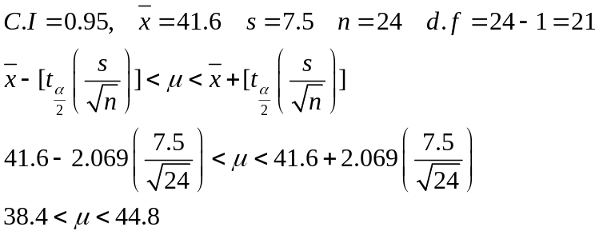
The 95% confidence interval of the true mean is .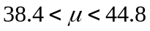

17. Costs for a 30-Second Spot on Cable Television The approximate costs for a 30-second spot for various cable networks in a random selection of cities are shown below. Estimate the true population mean cost for a 30-second advertisement on cable network with 90%
confidence.

14 55 165 9 15 66 23 30 150
22 12 13 54 73 55 41 78

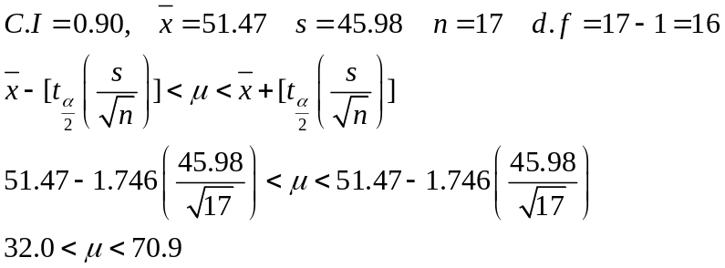
The 95% confidence interval of the true mean is 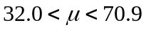.

Exercises 7-3 Pg380 # 1(b,c,d),2(a,b),7,8,13,15,16,17
1. In each case, find and.
b) n=200 and X=90
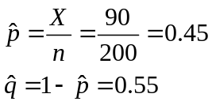
c) n=130 and X=60
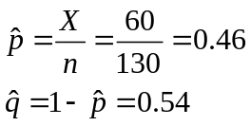
d) n=60 and X=35
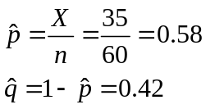

2. (ans) Find and for each percentage.( use each percentage for.)
a)15%
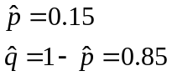
b) 37%
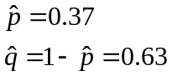

7. Work Interruptions A survey found that out of 200 workers, 168 said they were interrupted three or more times an hour by phone messages, faxes, etc. find the 90% confidence interval of the population proportion of workers who are interrupted three or more times an hour.
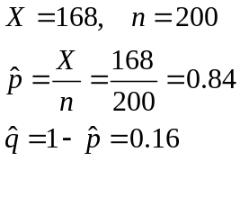Confidence Interval for a proportion: 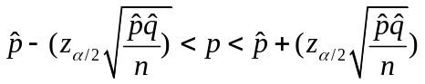
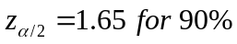
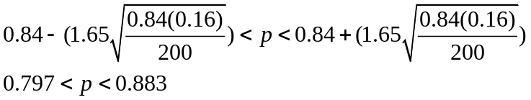
The 90% confidence interval of the population proportion of workers who are interrupted three or more times an hour is: 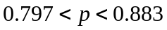

8. Travel Outer Space A CBS News/ New York Times poll found that 329 out of 763 adults said they would travel to outer space in their lifetime, given the chance. Estimate the true proportion of adults who would like to travel to outer space with 92% confidence.
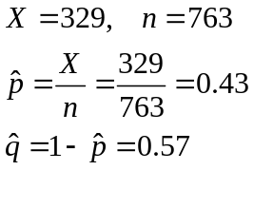 Confidence Interval for a proportion: 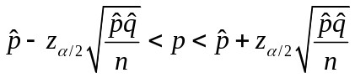
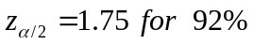
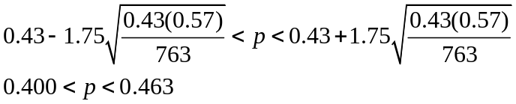
The 92% confidence interval of the true proportion of adults who would like to travel to outer space is: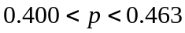

13. Financial Well-being in a Gallup poll of 1005 individuals, 452 thought they were worse off financially than a year ago. Find the 95% confidence interval for the true proportion of individuals that feel they are worse off financially.
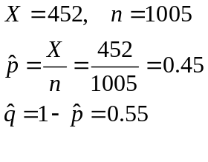 Confidence Interval for a proportion:
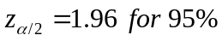
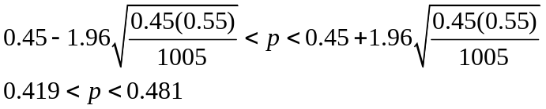
The 95% confidence interval for the true proportion of individuals that feel they are worse off financially is 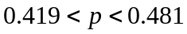

15. Vitamins for Women a medical researcher wishes to determine the percentage of females who take vitamins. He wishes to be 99% confident that the estimate is within 2 percentage points of the true proportion. A recent study of 180 females showed that 25% took vitamins.
a) How large should the sample size be?
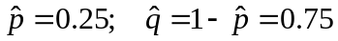
Formula to find the sample size: 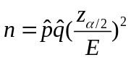
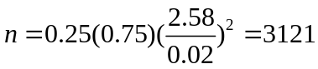
b) If no estimate of the sample proportion is available, how large should the sample be?
Formula to find the sample size
Since the 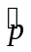is not available, use 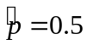
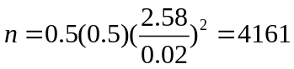
16. Windows a recent study indicated that 29% of the 100 women over age 55 in the study were widows.
a) How large a sample must one take to be 90% confident that the estimate is within 0.05 of the true proportion of women over ages 55 who are widows?
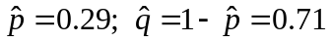
Formula to find the sample size:
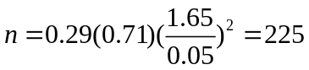
b) If no estimate of the sample proportion is available, how large should the sample be?
Formula to find the sample size:
Since the sample proportion is not available, use
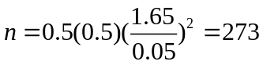

17. Direct Satellite Television It is believed that 25% of U.S. homes have a direct satellite television receiver. Section 7–3 Confidence Intervals and Sample Size for Proportions 381 7–29
How large a sample is necessary to estimate the true population of homes which do with 95% confidence and within 3 percentage points? How large a sample is necessary if nothing is known about the proportion?

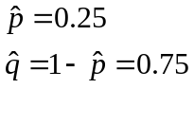
Formula to find the sample size:
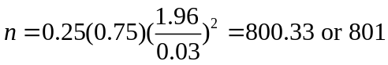
b) If no estimate of the sample proportion is available, how large should the sample be?
Formula to find the sample size:
Since the sample proportion is not provided, use 